***RL-3812-ICRGB***

***Specifications***

|  |  |  |  |
| --- | --- | --- | --- |
| **Picture** | **Dimension** | **Parameters** | |
| **3812** | **11(11)** | **Input voltage** | DC 24V |
| **Lamp power** | 2.88W |
| **Chip** | UCS 2903 |
| **LED chip** | SMD 3535 |
| **LEDs number** | 12 |
| **Color** | RGB programmable |
| **IP rating** | IP65 |
| **Beam angle** | ≥140° |
| **Lifespan** | ≥50000h |

***Features***

1. This product is made up of PCB. Milky/Transparent plastic cover and base, a couple of 3-pins male and female connectors. As well as a series of gluing process to ensure good water and UV resistance.
2. It is a RGB programmable product, can achieve many different light effects by using a LED controller such as K-1000c.
3. The features of this product are high brightness, low power dissipation, long lifespan, low voltage decline and excellent thermal management and lumen maintenance.
4. Customized requests are available, for example: logo, waterproof connectors, transparent or milky cover, and length of cables.
5. This product has CE and RoHS certifications.

***Applications***

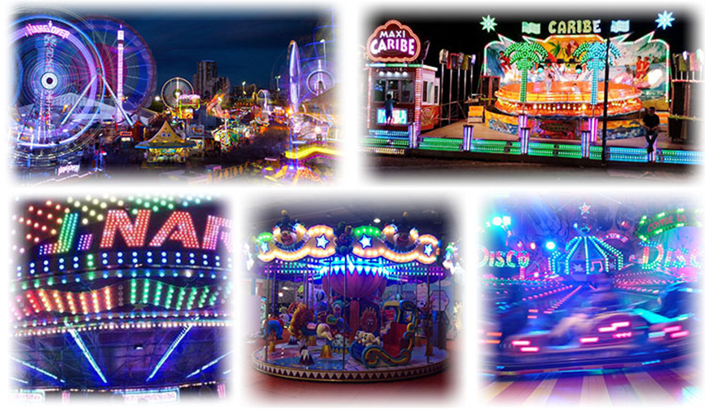

1. **Amusement Park Rides Light**

Ferris wheel, Carousels, Pirate ship, Pendulum, Bumper car, Tower and so on.

1. **Advertisement Outdoor Signboard Backlight**

Logo, Signage, Channel letter, Signs, Exposed luminous characters, Billboard and so on.

1. **Stage Decoration Light**

KTV, Disco, Bar, Night club and other stage light.

1. **Commercial Light**

Hotel, Shopping mall, Theater, Square and so on.

1. **Kids Rides Decoration**

Castles, Robot, Mini carousels, Car, Mini train etc.

***Packing & Weight***

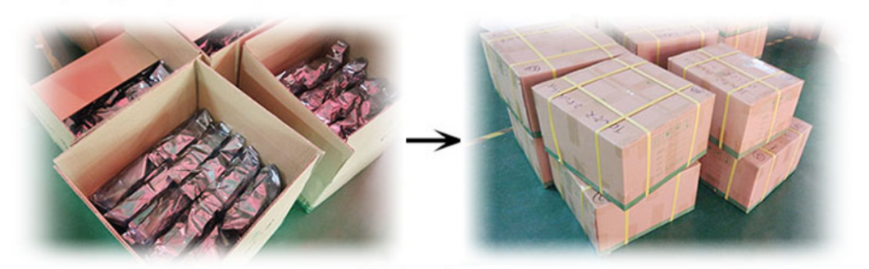

|  |  |  |  |  |
| --- | --- | --- | --- | --- |
| **Weight/100pcs** | **Pieces/bag** | **Pieces/carton** | **G.W/carton** | **Carton size** |
| 1.4kg | 100pcs | 480pcs | 16kg | 46.5cm*46cm*28cm |

***Connection***

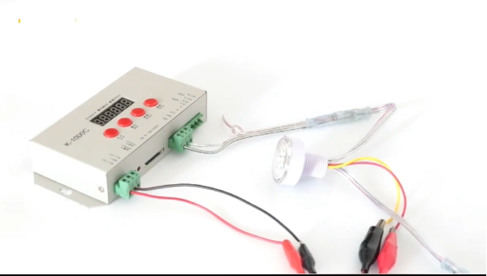

**Notes:**

1. Male connector (with pins) is signal input port, female connector (without pins) is signal output port.
2. We suggest that every 20pcs lights connect to the power supply in parallel to avoid voltage decline.
3. One controller can only support up to 2000 pixels, more than 2000 pixels, you need to cascade with multiple controllers.